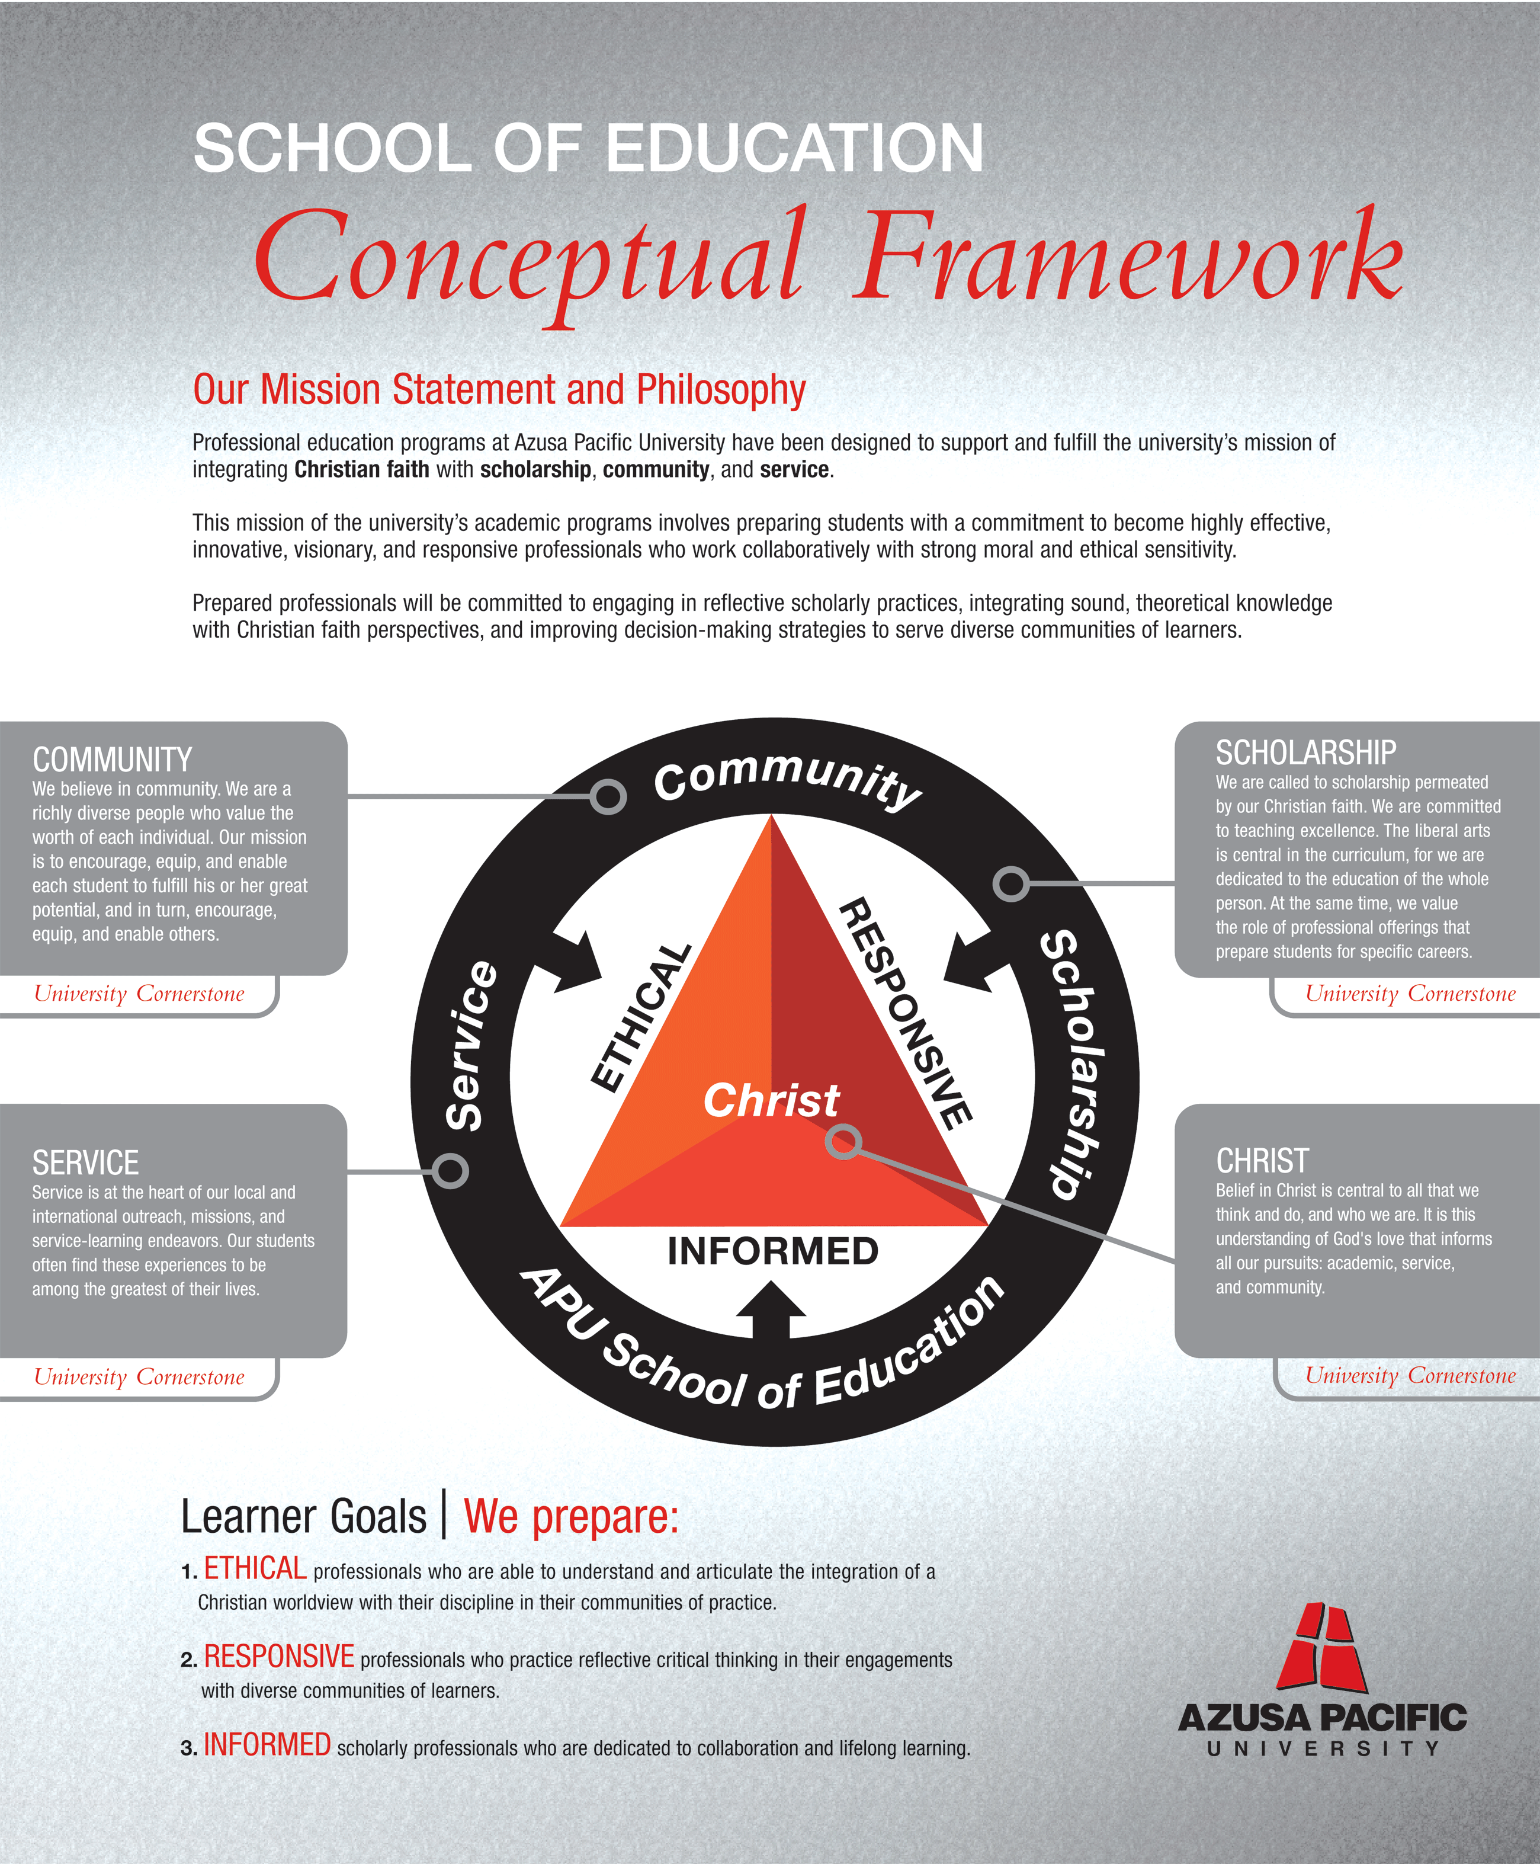
EDUC 522 Learning in the 21st Century
MA in Educational Technology and Learning
Innovative Educational Technology & Physical Education
Nicol Malone, MA • nicolmalone@hotmail.com
APU Mission Statement
Azusa Pacific University is an evangelical Christian community of disciples and scholars who seek to advance the work of God in the world through academic excellence in liberal arts and professional programs of higher education that encourage students to develop a Christian perspective on truth and life.
Ed Tech & Learning Mission Statement
The Master of Arts in Educational Technology and Learning Program reflects Christ’s calling to excellence in honoring God in all that we do by impacting the lives of our students to become more effective and responsive teachers, and thus impacting their own students’ lives and educational experiences.
Program Objectives
Students will have the opportunity to:
*Examine, explore, and articulate their role as a Christian educator. Plan and design effective learning environments and experiences supported by technology to maximize student learning.
*Demonstrate a sound understanding of technology operations and concepts.
*Apply technology to facilitate a variety of effective assessment and evaluation strategies.
*Understand the social, ethical, legal and human issues surrounding the issue of use of technology in Pre K - 14 schools and apply that understanding in practice.
*Use technology to support learner-centered strategies that address the diverse needs of students.
Department of Advanced Studies
Vision Statement
To develop highly effective, innovative, visionary educators and scholarly practitioners of high moral and ethical character based upon Christian values and principles. Our vision is grounded in the four cornerstones that define the mission of Azusa Pacific University: Christ, Scholarship, Community, and Service.
School of Education
Learner Goals
EDUC 522 Focuses on the three Learner Goals:
1. Ethical professionals who are able to understand and articulate the integration of a Christian worldview with their discipline in their communities of practice.
2. Responsive professionals who practice reflective critical thinking in their engagements with diverse communities of learners.
3 . Informed scholarly professional who are dedicated to collaboration and life long learning.
Academic Integrity
The maintenance of academic integrity and quality education is the responsibility of each student at Azusa Pacific University. It is expected that all students will do their own work. Cheating or plagiarism will result in failure of this class. Academic dishonesty is a serious offense that diminishes the quality of scholarship and defrauds those who defend upon the integrity of the educational system. In the Ed Tech program this includes use of templates, web designs, and any other unauthorized material (i.e. graphics used without permission, etc).
Students with Disabilities Clause
Students with disabilities: Any student in this course who has a disability that might prevent him/her from fully demonstrating his/her abilities should meet with an advisor in the Learning Enrichment Center as soon as possible to initiate disability verification and discuss accommodations that may be necessary to ensure your full participation in the successful completion of course requirements.
Class Participation
Class participation is essential. Weekly participation in course assignments and threaded discussions will enable all students to benefit from knowledge, experiences, and creative thought processes of each other. Together, we will create a truly meaningful learning experience for all members of the class. It is expected that all students read, reflect upon, and respond to online articles and threaded discussion posts of other students. Online posts are expected to be thoughtful, academically and spiritually sound, and constructive. It is also expected that students complete all projects and other assignments before each class meeting.
EDUC 522 Learning in the 21st Century
MA in Educational Technology and Learning
Innovative Educational Technology & Physical Education
Nicol Malone, MA • nicolmalone@hotmail.com

Multiple Intelligence and Educational Technology
Course Description
Professional educators apply the latest research finding of contemporary psychologists and learning theorists to the challenges classroom motivation, discipline, individual differences, learning styles, and evaluation.
ISTE Nets
This course focuses on the following ISTE National Educational Technology Standards for Teachers: 2B, 3B, 4B, 4C, 6B, and 6C. Go to http://www.iste.org for a detailed listing of these standards. The activities / tasks are designed to assist students in moving to a level of proficiency necessary to complete the remainder of the Master of Arts in Educational Technology and Learning coursework. All work must be completed by the due dates specified in the course syllabus.
Recommended Text
1. McKenzie, W. (2005). Multiple Intelligences and Instructional Technology (2nd ed.). Eugene, Oregon: International Society for Technology in Education (ISTE).
Optional Text:
1. Silver, H. F., Strong, R. W., & Perini, M. J. (2000). So Each May Learn. Alexandria, VA: Association for Supervision and Curriculum Development. (ISBN 0-87120-387-1)
2. Pink, Daniel (2006). A Whole New Mind: Why Right-Brainers Will Rule the Future. Riverhead Trade; Rep Upd edition (ISBN 1594481717)
3. McKenzie, W. (2004). Standards-based lessons for tech-savvy students a multiple intelligences approach. Worthington, OH: Linworth Pub.
Grade Evaluation
These activities / tasks are designed to be embedded in real, purposeful activities that can be applied to professional work or goals. By sharing projects and ideas together, we benefit from the unique perspectives and strengths of each other. Sharing our work in a professional environment benefits our professional practice as well as personal insight and knowledge base.
Create website/blog and set up google reader. .............................................................. 20 points
Discussions / Weekly Reading. .........................................................................................30 points
Chapter and MI Domain Presentations (vodcast)....>........................................................20 points
Bloom / Gardner activity grid (McKenzie p.36, Silver p. 34-35) . .................................... 30 points
Multiple Intelligences Lesson Plan (McKenzie p. 49, 76, 92, Silver ch. 4) . ......................30 points
Student Project Rubric (McKenzie p.161-171, Silver ch. 5). ........................................... 10 points
Multiple Intelligences Unit Plan (McKenzie p. 100, 123, 137-139, Silver appendices) ….60 points
Total Points: . ....................................................................................................................200 points
Course activities
Projects are intended to provide opportunities for meaningful application of required text reading, online articles, threaded discussion, and other daily professional experiences of class participants. It is imperative that students make every attempt to develop projects with direct relevance and application to current teaching/educational situations. Organizational charts, sample projects, and selfcheck rubrics are embedded in course readings. Other resources will be available online in the Blog section of this website for reference. If at any time you need further clarification regarding any course project, or if you simply want to brainstorm a bit, please feel free to contact me by e-mail or telephone. I welcome the opportunity to help you on your journey!
Bloom/Gardner Activity Grid
Resources: McKenzie pp.12, 13, 15, 36, Silver p. 34-35,
Students will complete a grid of activities that address both Gardner’s Multiple Intelligences and Bloom’s taxonomy. A full project description and sample of this activity will be addressed in class.
Multiple Intelligence Lesson Plan
Resources: McKenzie pp. 49, 76, 92, Silver ch. 4
Using the ideas and resources available in the pages listed above, students will create or redesign a technology infused lesson plan to include adaptations for at least 2 of the 8 multiple intelligences.
Student Project Rubric
Resources pp.161-171, Silver ch. 5
Using the ideas and resources available on pages listed above, create a grading rubric for their Multiple Intelligences lesson plan.
Multiple Intelligence Unit Plan
Resources: McKenzie pp. 100, 123, 137-139, Silver appendices
Students will develop or redesign a unit that incorporates at least one activity for each of the intelligences. The unit plan will be presented in a using the template provided. The chart should list activities, intelligences, state standards and technologies that will be incorporated.
Grading Policy: Your final grade will be based on the following point ranges:
188-200 = A
180-187 = A-
176-179 = B+
166-175 = B
160-167 = B-
140-159 = C
Below 139 = F

